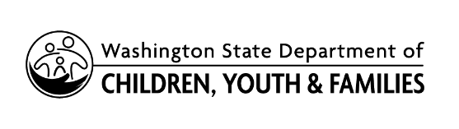 | Parent Consent to Transfer ELMS  Records between ECEAP Contractors

Child Name: |  |  | Childs Birthdate:

I, |  | , consent to allow the Department of Children,
Youth, and Families to release the Early Childhood Education and Assistance Program (ECEAP)
records for the child named above to
(Name of new ECEAP Contractor).

I understand that these records are stored on the secure, online Early Learning Management System (ELMS) and include, but are not limited to, the information I provided at the time of my child’s initial application to ECEAP; information about my child’s medical and dental status; vision, hearing and development screening results; and dates and topics of parent-teacher conferences and family support meetings

Signature |  | Relationship to Child |  | Date

