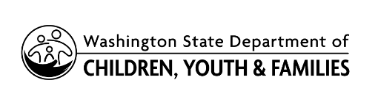 | Citizen Review Panel  Confidentiality Agreement

The 1996 amendment to the Child Abuse Prevention and Treatment Act (CAPTA) requires states that receive funding for the Child Abuse and Neglect State Grants Program establish Citizen Review Panels. Under federal statute, each Citizen Review Panel is required to review the compliance of state and local Child Protective Services (CPS) agencies in the discharge of their responsibilities with respect to the following: the State CAPTA Plan, coordination with the Title IV-E foster care and adoption programs, review of child fatalities and near fatalities, and other criteria the panel considers important.
By signing this confidentiality agreement, the undersigned agree to discharge these duties as an individual panel member and are required to maintain confidentiality. Panel members, staff, and any quest are bound by the confidentiality restrictions in section 106(c)(B)(i) of CAPTA. The undersigned further agree that they will not disclose to any person or government official any identifying information about any specific child protection case with respect to which the panel is providing information. The undersigned also agree that they shall not make public any other information unless authorized by State or federal law. The undersigned, as members of this Citizen Review Panel pledge to maintain confidentiality as required by state and federal statute.

Citizen Review Panel: Meeting Date:
Member Name (Printed) | Member Signature | Date

