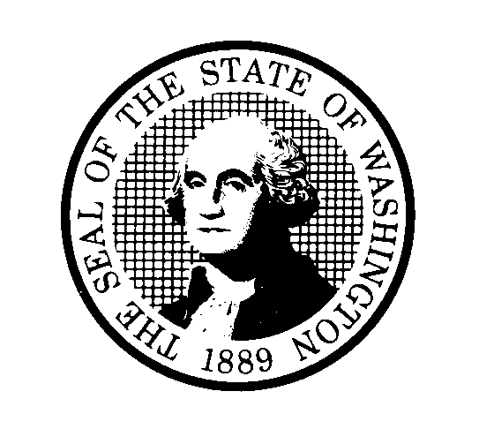
DEPARTMENT OF CHILDREN, YOUTH, AND FAMILIES (DCYF)
Certification Regarding Environmental Tobacco Smoke
Public Law 103227, Part C Environmental Tobacco Smoke, also known as the Pro Children Act of 1994, requires that smoking not be permitted in any portion of any indoor routinely owned or leased or contracted for by an entity and used routinely or regularly for provision of health, day care, education, or library services to children under the age of 18, if the services are funded by Federal programs either directly or through State or local governments, by Federal grant, contract, loan, or loan guarantee. The law does not apply to children’s services provided in private residences, facilities funded solely by Medicare or Medicaid funds, and portions of facilities used for inpatient drug or alcohol treatment. Failure to comply with the provisions of the law may result in the imposition of a civil monetary penalty of up to $1000 per day and/or the imposition of an administrative compliance order on the responsible entity by signing and submitting this application the applicant / grantee certifies that it will comply with the requirements of the Act.
The applicant/grantee further agrees that it will require the language of this certification be included in any subawards which contain provisions for the children’s services and that all subgrantees shall certify accordingly.
ORGANIZATION
DEPARTMENT OF CHILDREN, YOUTH, AND FAMILIES
AUTHORIZED SIGNATURE | TITLE  SECRETARY | DATE

