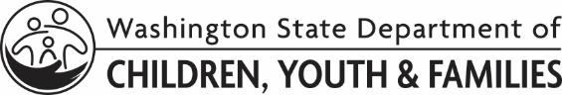 |  | LICENSING DIVISION (LD)  Individual Training Plan
At the time of renewal, you are required to have completed 24 hours of training. This includes at least one training from each of the following competency categories:
- Understanding and Working Within the Child Welfare System
- Parenting and Family Management
- Caregiver Self-Awareness and Development
- Racial Equity and Social Justice
Training Goal / Competency: Choose an item.
Course:
Course:
Course:
Training Goal / Competency: Choose an item.
Course:
Course:
Course:
Training Goal / Competency: Choose an item.
Course:
Course:
Course:
Training Goal / Competency: Choose an item.
Course:
Course:
Course:
APPLICANT A NAME |  |  | DATE
APPLICANT A SIGNATURE |  |  | DATE OF BIRTH
APPLICANT B NAME |  |  | DATE
APPLICANT B SIGNATURE |  |  | DATE OF BIRTH
LD/CPA STAFF NAME | LD/CPA STAFF SIGNATURE |  | DATE

