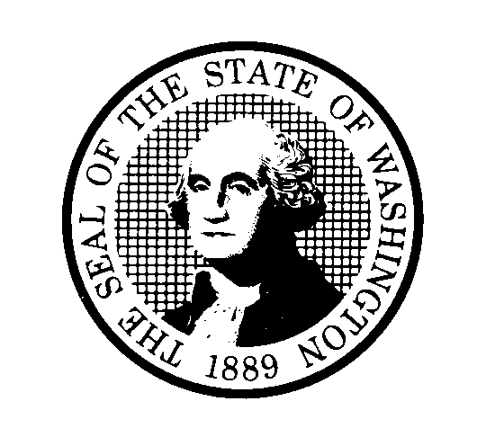
DEPARTMENT OF CHILDREN, YOUTH, AND FAMILIES (DCYF)
Reconsideration Request
NAME | PHONE
STARS ID NUMBER | EMAIL
MAILING ADDRESS |  | CITY | STATE | ZIP
PLEASE ANSWER THE FOLLOWING QUESTIONS
What were the circumstances that led to your conviction or negative action?
Has the reason for disqualification recently been dismissed or reduced? If so provide supporting documentation.
Describe the following since the conviction or negative action:

- Classes taken:
- Education
- Training
Please attach any updated documentation that provides evidence to support the above information.
Examples: New court documents, class certificates, etc.
SIGNATURE | PHONE

DEPARTMENT OF CHILDREN, YOUTH, AND FAMILIES (DCYF)
Reconsideration Request Instructions
Be advised that a reconsideration will not be accepted at any point for a permanently disqualifying conviction under WAC 110-06-0120(1), and will not be accepted within 5 years of the conviction date for crimes listed in WAC 110-06-0120(2).

For cases where reconsideration can be offered, the Department of Children, Youth, and Families (DCYF) will review a Reconsideration Request if new supporting evidence is provided.

We will examine all new evidence you have and make a determination based on that information.

The signed reconsideration form and supporting documents must be sent to DCYF within 28 calendar days of when the disqualification letter was signed for by someone, at the mailing address.

The written request must be sent to DCYF in some manner that proves DCYF received it (ex. certified mail via the United States Postal Service).

It must be received no later than 5:00pm on the 28th day. A request reaching DCYF after 5:00pm on any given day will be considered to have been received on the next business day.

Please send your request to:
Department of Children, Youth and Families
Attn: Background Check Unit (BCU)
PO Box 40971
Olympia, WA 98504-0971

