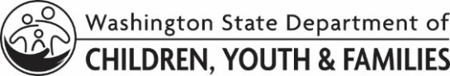 | LICENSING DIVISION (LD)  Vaccination Agreements (Certified Respite)
Agreements
As a certified respite provider, you are expected to meet the needs of the children you are caring for. When caring for medically fragile children or children under the age of 2, you need to:

- get the Influenza vaccine by October 31 each year.

- be fully vaccinated against Pertussis.

- maintain verification of these vaccinations.

If you cannot get either of these immunizations for medical reasons, a licensed healthcare provider must fill out a Vaccine Exemption (DCYF 15-455) indicating the immunization is contrary to your health.

If you are having difficulty meeting this requirement, please discuss with your assigned worker.

Influenza
I agree that, if I care for medically fragile children and/or children under the age of 2, I will get the Influenza vaccine by October 31 each year.

OR

I cannot get the Influenza vaccine as it is contrary to my health. I agree that, if I provide care for medically fragile children and/or children under the age of 2, a licensed healthcare provider will complete a Vaccine Exemption (DCYF 15-455).

Pertussis
I agree that, if I care for medically fragile children and/or children under the age of 2, I will be fully vaccinated against Pertussis.

OR

I cannot get the Pertussis vaccine as it is contrary to my health. I agree that, if I provide care for medically fragile children and/or children under the age of 2, a licensed healthcare provider will complete a Vaccine Exemption (DCYF 15-455).

Applicant Information
NAME |  | DATE OF BIRTH
SIGNATURE |  | DATE

