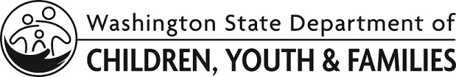 | ECEAP Professional Development Plan  Family Support Staff

Please see ECEAP Performance Standards

for descriptions of this position, qualifications, and professional development plan requirements.

Name |  | Supervisor
Position |  | Date of Hire

Agreement
I understand that I have been hired provisionally as a family support staff and it is my responsibility to:

- Obtain education to obtain ECEAP family support staff qualifications within five years of my date of hire for this position.
- Make yearly progress to meet the required qualifications.
- Upon completion of this Plan, submit a Staff Qualifications Application in MERIT and email or mail in copies of my transcripts and other documentation.

Current Qualifications
List related information from diplomas or transcripts:

Degrees or Certificates
ECE Credit

My Plan
I intend to meet this requirement by (date) by completing (check one):
An associate or higher degree in adult education, human development, human services, family support, social work, early childhood education, child development, psychology or related field directly related to your job responsibilities
An associate or higher degree with the equivalent of 30 college quarter credits in related fields of adult education, human development, human services, family support, social work, early childhood education, child development, psychology or related field directly related to your job responsibilities
A current Child Development Associate (CDA) Home Visitor credential awarded by the Council for Professional Recognition
A Washington State ECE Short Certificate of Specialization in Home Visiting
A DCYF-approved credential from one of the following comprehensive and competency-based Family/Social Service training programs that increases knowledge and skills in providing direct services to families:
- A Family Service Credential from The Portage Project
- A Family Support Core Certificate from Edmonds Community College
- A Family Support Studies Certificate from Edmonds Community College
- A National Family Service Credential from the University of Connecticut
- A Human Services Case Management and Administration Certificate from Washington State University with a case management focus
- A credential from a comprehensive and competency-based Family/Social Service program not mentioned above that increases knowledge and skills in providing direct services to families (subject to DCYF approval)

Courses to be taken (continue on additional page if needed):
Course Title | Where | Credit of Hours | Completion Date

Employee Signature |  | Date
Supervisor Signature |  | Date

Copy Distribution: Personnel File and Employee

