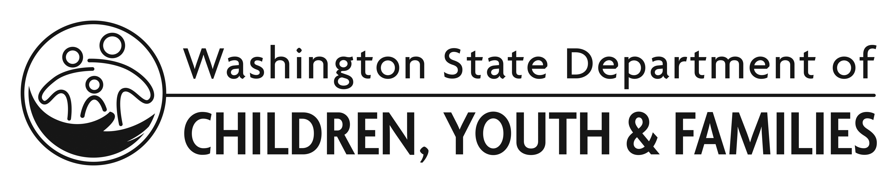 | Exhibit B: Letters of Support and Collaboration

Organization Name

For current ECEAP Contractors, submitting letters is optional.
Scoring will be based on the most recent data collected by DCYF on parent engagement and community partnerships and/or any letters submitted. If you believe your application would benefit from information other than what DCYF already has in ELMS, submitted deliverables, or information gathered during monitoring visits, you may choose the option of submitting letters. This does not guarantee more points during the scoring process. Since this Exhibit is scored at the contractor level, there is no benefit to submitting letters about specific proposed sites.

For Applicants who are not a current ECEAP Contractor, submitting letters is required.
- Submit at least four letters of support and collaboration to the Application.
- One must be from a family who has received your services.
- One must be from one of your local school districts.
- Two must be from community partners that you would work with to provide ECEAP services.

Send these in a single document, titled:
“Exhibit B: Letters of Support and Collaboration – YOUR ORGANIZATION NAME.”

