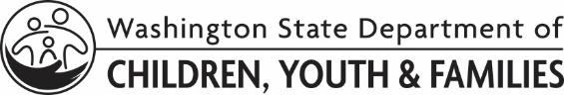 | Licensing Division Practice Change Request
Any LD staff may use this form to submit innovative practice, policy, or protocol ideas to LD leadership.
Directions: Please fill out as much as you can and send to: dcyf.ldinnovationrequests@dcyf.wa.gov
NOTE:
- For WA CAP (Binti) requests or ideas, email dcyf.caregiverportal@dcyf.wa.gov
- For WA Compass requests or ideas, email dcyf.wacompass@dcyf.wa.gov
- For LD communication requests or ideas (e.g., publications, documents, etc.), fill out and send Form 02-005 Licensing Division Communications Request

Requestor Name: |  | Date:
Description of idea: Please tell us about your idea for changing practice, policy, or protocol:

Why do you think this change/idea is important? (examples: cost savings, streamline processes, improve practice, etc.)

Who do you think might be positively impacted by your idea? (examples: foster parents, child care providers, community partners, LD staff, etc.)

Racial Equity and Social Justice Lens: How will your idea impact the following? Please use the DCYF Racial Equity and Social Justice Tools and Resources for guidance in this section.
- Tribal governments and citizens

- Children, youth, families, providers, and/or communities of color

- LGBTQIA+ community

- Other historically excluded and marginalized communities

To be completed by Program Supervisor
Axosoft number assigned: | Date:

