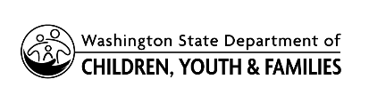 | Child Care Stabilization Grant Spend Period Extension Request Form

Facility Name |  |  | Licensed Provider ID Number:
Primary Contact Number |  |  | Email
Amount of Unspent Grant Funds: |  |  | Original Award Date:
The maximum spend period extension a provider can request is to August 31, 2023 or three months after the provider’s original spend period end date, whichever is longer.
Requested spend period end date:

Reason grant funds could not be spent in the timeframe listed in the terms & conditions of this grant:

Plan for spending grant funds within the extended spend period:

Terms and Conditions: By signing this application, you (the facility named in this application) agree to the following:

- You will only spend the grant funds on the purchases listed on this form

- Your facility will remain open until the end of your extended spend period

- You will keep all receipts from purchases made with Child Care Stabilization Grant money for five (5) years. The Department of Children, Youth, and Families may ask you to provide these receipts.

Signature |  | Print Name |  | Date

