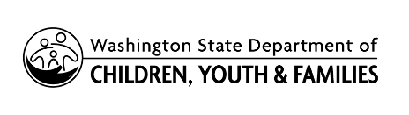 | 2022 Spring HVSA Expansion Funding Opportunity  Letter of Intent to Apply

Instructions:
Complete this Letter of Intent to Apply template.
Submit the form electronically to home.visiting@dcyf.wa.gov by noon PST March 11, 2022. You must submit an LOI if you intend to apply for funds through this funding opportunity; applications will not be accepted if an LOI was not submitted on or by March 11, 2022.

Organization/Program Information
Organization Name
Home Visiting Program Name
Program Model

Program Contact
Grant Writer or Home Visiting Manager Information
First Name |  | Last Name
Title
E-mail |  | Phone Number

Anticipated Annual Funding Request
Please note, this is anticipated and may change in your submitted application

Anticipated 12-Month Ongoing Budget (7/1/22-6/30/23)  for new/expansion services only (not current budget) | $

Anticipated Caseload and Service Populations/Communities
Please note, this is anticipated and may change in your submitted application

Anticipated New Caseload
Number of Families to be served in a typical month

Anticipated Priority Populations to be Served (please check all apply)
American Indian/Alaska Native Families
Black/African American Families
Pacific Islander Families
Hispanic Families
Immigrant/Refugee Families
Families from Rural or Remote/Frontier Communities

Anticipated Priority Tribe/School Locale(s) or Other Service Area*
Please use the Guidance Document Section 2 Priorities for this Funding Opportunity for School Locale definitions

