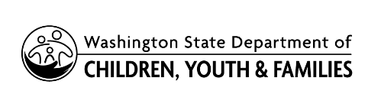 | Request for Extension and Disability  Verification For Youth Over Age 18

If you are requesting an extension of adoption support beyond your child’s eighteenth birthday, please return this form along with your child’s high school enrollment verification. You will need to provide the requested documentation from your child’s medical care provider or school if he/she has a disability, as requested below.

CHILD’S NAME | DATE OF BIRTH | Does your child have a disability?  Yes No

ADOPTIVE PARENT NAME (S) | EMAIL
ADDRESS | PHONE

 |  |  | Yes | No
1. | Does your child have physical limitations due to injury or disease?  If yes, please attach current doctor’s report.
 | Diagnosis:
2. | Does your child have emotional or behavioral problems?  If yes, please attach current therapeutic report.
 | Diagnosis:
3. | Does your child have an IEP or 504 plan?  If yes, please attach current school documentation.
 | Diagnosis:
4. | Does your child live in your home?
 | If not, where is your child residing:
5. | Is your child receiving Supplemental Security Income (SSI)?  Type Amount
6. | Will you still be providing financial support after your child turns 18?
7. | Are you requesting Medicaid be extended for your child?
Parent Signature |  |  | Date

