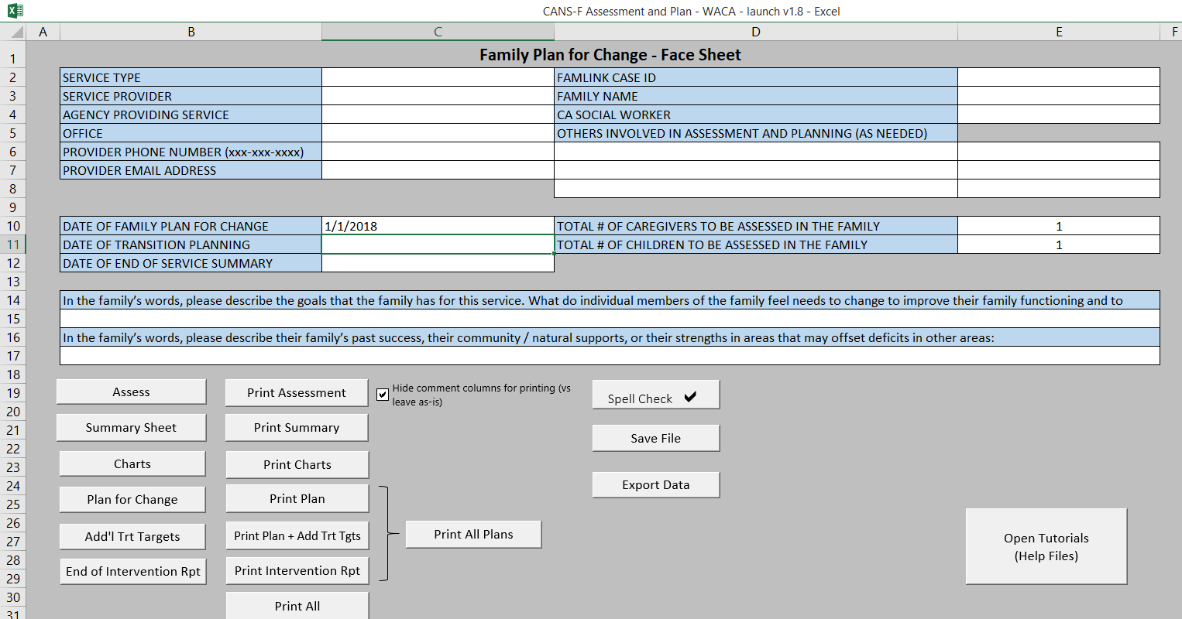
*?* *?*
*?* *?*
*?* *?*
*?*
*?* *?*
*?*

*?* *?*
*?* *?*
*?*

*?*

*?*

*?* *?* *?*

*?* *?* *?*

*?* *?*
*?*
*?* *?*

*?* *?* *?* *?*

*?* *?*

*?*

Explanation of Dates
Date of Plan for Change: This is the date in which you complete the initial assessment with the family.
Date of Transition Planning: This is the date of the first re-assessment. The point at which this is to occur will be based on the particular service you are providing.
Date of End of Service Summary: This is the date of your closing session with the family and final re-assessment.
How to re-assess: Revisit all items scored as a two or three, as well as any other item you/the family/social worker feel needs to be revisited.

Drop Outs: If a family does not successfully complete services a closing CANS-F needs to be submitted. A closing CANS-F should include detailed information regarding the reason and circumstances for the families failure to complete the service. Examples could include: a list of missed appointments, a statement “family has decided to discontinue services because…..”.

In some situations you will be carrying the initial assessment forward into the final assessment as you will not be able to reassess with the family. If skills or services have been delivered from the Family Plan for Change please reassess the targeted needs that were addressed and discuss the outcomes.

Example Shared Vision Statement:
The family would like to improve their communication and work on their relationships. Mom reports “I feel like I don’t always understand what’s going on in her life and I feel like I’m talking to a brick wall”. Jessica reports “I don’t feel like I can open up to my mom”. Everyone also reports they would benefit from learning distress tolerance skills. Mom: “I tend to shut down and just avoid my problems”. Jessica: “I feel overwhelmed and don’t know what to do about it”.

Example of Family Strengths:
The family is open to services, Mom reports “I’ll do anything to make my family better”. The family is involved in church and has a good natural support system in the form of extended family and friends. Jessica reports “I get along really well with grandma and I love when she can come by”. Mom is very receptive to feedback but sometimes need help in advocating for her family. Jessica does well in school and reports “tons of friends I can trust”.

Saving: This button works the same as the “Save As” command.

Exporting Data: This will generate a new Excel document that contains all of the assessment data (scores only) from the CANS-F assessment. Do not change the name of the file or add any additional information to it or it will invalidate the data when you upload it (although you will not receive an error and it will appear as though you have successfully uploaded). If you are uploading yourself, you should receive a weekly email from TCOM reminding you to upload and providing a link to do so.

How to save as a PDF: Click whichever print button is relevant to what you are saving. Under the dropdown list to select a printer, select Microsoft Print to PDF, click OK. After a brief pause, this will open a save file box allowing you to save as a PDF.

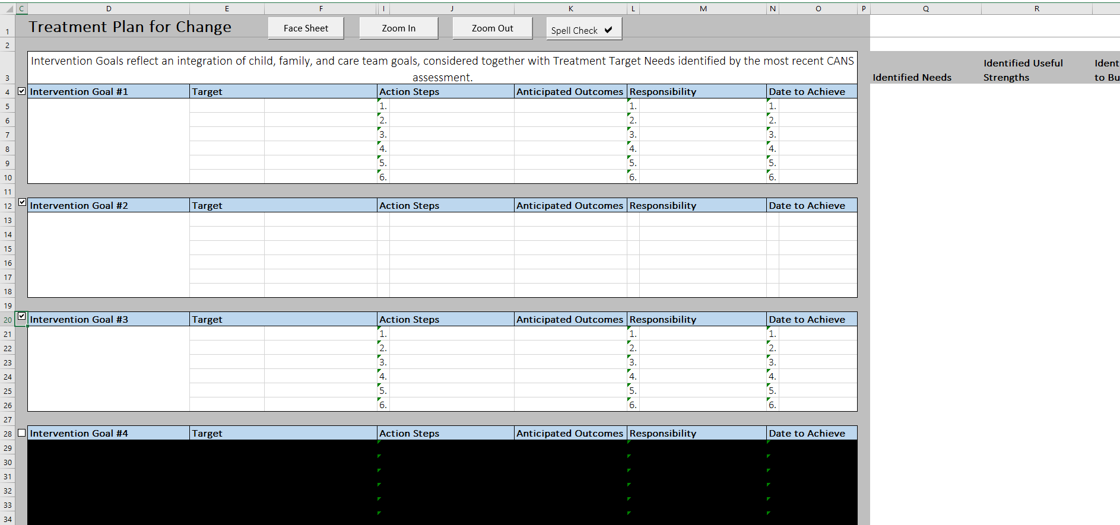

*?* *?* *?* *?* *?* *?* *?* *

*?*

*?*

*?*

12.
Issue with the Drop Down List:
If you are having issues finding an identified need in the drop down box, here’s a quick work around. Make sure the previous field (“Needs”) is empty. Now you can type any CANS-F item into this field (just check your spelling). Now you can go back and select either Needs in the previous field.
3
Anticipated Outcomes:
This field has no validation (i.e. you can type anything here). You can enter multiple CANS-F items in this field. Again, please note, if you enter multiple CANS-F items in this field, it will not cross them out in the lists on the right side of the page. It’s okay, just double check you’ve included all needs and strengths/strengths to build in your treatment plan.
45678910
Goals: DCYF requests that treatment plans be focused on Immediate Safety Concerns followed by long term safety and placement concerns.

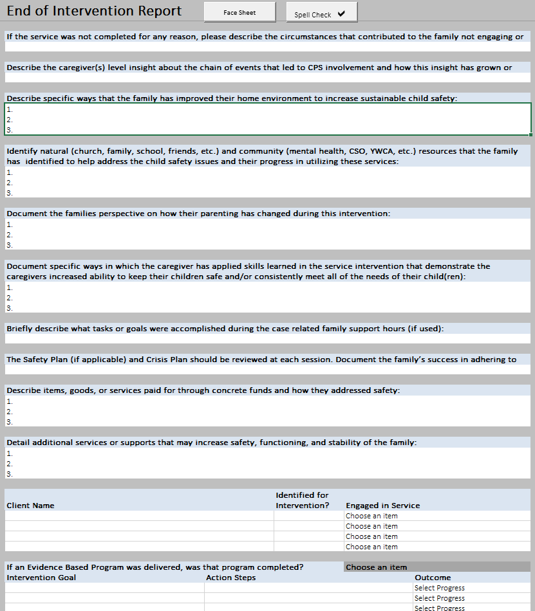
.

*?*

*?*

*?*

*?*

*?*

*?*

*?*

*?*

*?*

*?*

*?* *?*

*?* *?* *?*
1
Service not Completed: This box MUST be completed when a family drops out. Please explain what prevented the family from completing the services or the circumstances that led to the family stopping services or your agency from stopping services.
2
3
4
5
6
7
8
9
10
11
12
13
14
15

